Project 3
Botnet PCAP Trace Analysis Using Wireshark
Objective
- To use Wireshark to analyze network packets of a botnet.
Description
- Students may work individually or form a team of up to four members to complete the project. While teamwork is allowed, students are encouraged to complete the project on their own.
- All students must submit their own answers to this project.
- Graduate students are required to answer all questions.
- Undergraduate students may select questions totaling 24 points to answer. The maximum score for an undergraduate student will be capped at 24, regardless of how many questions are attempted.
Submission
- All students must complete Project 3, which is listed under the Quiz category;
- All students must also submit an analysis report (using this template) explaining how the results were derived from the given trace. Students working in the same team may submit an identical report; however, each student must upload the report individually.
- For your answer to each question in the analysis report, please include the screenshot of the relevant code snippet and your analysis.
Pcap File and Additional Information
- You can download the pcap file of the network traffic from this link.
- You will find the source code of the bot in HW3 helpful.
- You will find the IRC protocol useful for this project.
The Tool
- You are recommended to use Wireshark to complete this project.
- You may want to use the Wireshark's "filter" functions to expediate your analysis.

Your Name: Bhuwan Pandey
UID: U01155118

Q1. Which of the following IP addresses is the botnet’s command-and-control (C2) server?

192.168.1.128
192.168.1.129
192.168.1.132
192.168.1.134

Answer: 192.168.1.128 seems like the botnet’s C2 server as multiple hosts (192.168.1.129, .130, .132, .134) are communicating with 192.168.1.128
Also, we can see many IRC PRIVMSG, PING, and PONG messages centered around 192.168.1.128.
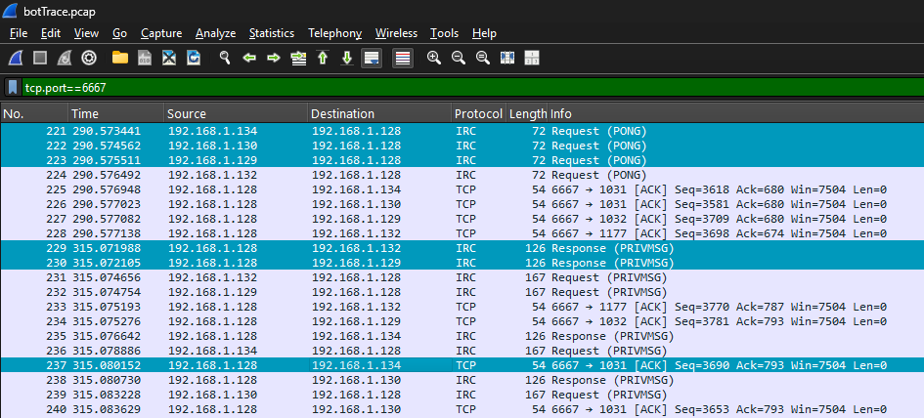

Q2. Identify the port number used by the botnet’s command-and-control (C2) server to control bots.
6667, 80, 443, 53
Answer: In reference to above screenshot (last highlighted row) and the reason being botnet using standard IRC on port 6667, we can clearly acknowledge that the port number used was 6667.

Q3. What application-layer protocol is used by the botnet’s command-and-control (C2) channel?
IRC, HTTP, HTTPS, FTP
Answer: IRC is used as application-layer protocol because we can clearly see IRC shows in Protocol column and message like PRIVMSG, PING, PONG are exchanged.


Q4. Identify bots' IP addresses.
192.168.1.128
192.168.1.129
192.168.1.130
192.168.1.132
192.168.1.134

Answer: 192.168.1.129, 192.168.1.130, 192.168.1.132, 192.168.1.134 are the bot’s IP addresses as they are observed communicating with the C2 server (192.168.1.128), indicating they are compromised hosts (bots).
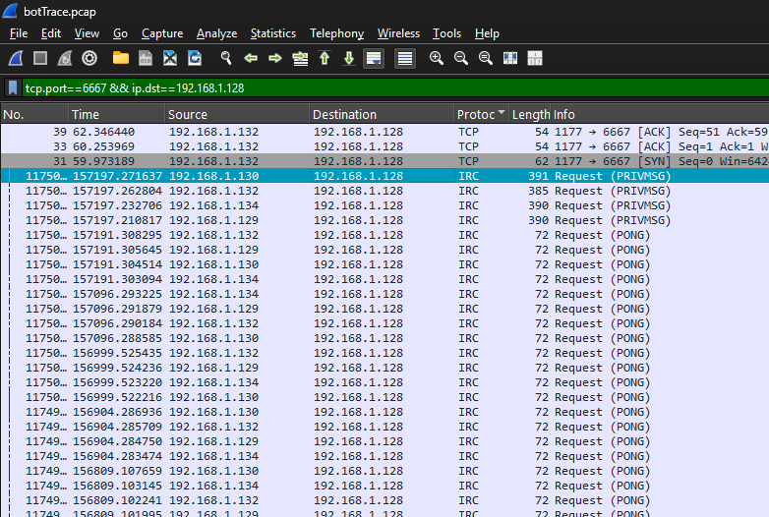.

Q5. What is the most likely password used by the botmaster to log in to the bots?
12345, password, ATtaCK!, test
Answer: The password is test as botmaster issues .login 12345, and all bots respond with “Password accepted,” confirming the password. Below image shows partial result after following one of the IRC packet.
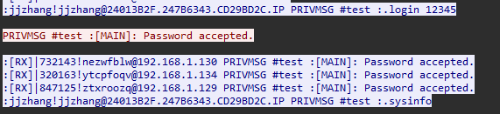

Q6. What is the most likely version of the operating system on the compromised bots?
Windows XP (5.1, Build 2600)
Windows 2000 (5.1, Build 2600)
Windows NT (5.1, Build 2600)
None of above
Answer: The most likely version of the operating system on the compromised bots is Windows XP (5.1, Build 2600) as all bots report the same OS version.

Q7. Which of the following commands is used by the botmaster to scan the network of compromised hosts (bots)?
.advscan, .sysinfo, .login, .flusharp
Answer: Following up on a stream, we can see that .advscan is used to scan the network:

Q8. All compromised hosts (bots) use the same Microsoft Windows Product ID CD Key.
True/False
Answer: True, because as we can see on the stream follow up, all the bots return the same Product ID for the .getcdkeys command.
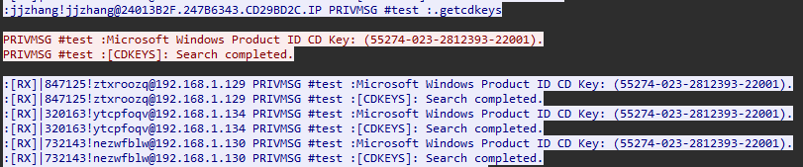

Q9. The botmaster issued the command dns www.sina.com.cn instructing each bot to perform a DNS query for that domain. Which bots followed this instruction and actually sent the DNS query?
192.168.1.129
192.168.1.130
192.168.1.132
192.168.1.134
Answer: The bots following the instruction and actually sent the DNS query (even though the resolution failed) are 192.168.1.129, 192.168.1.130, and 192.168.1.134 as we can see in the below image of the same follow up stream result.
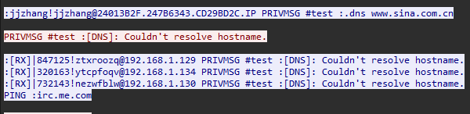

Q10. Which of the following commands were issued by the attacker to the bots?
.flusharp
.getcdkeys
.procs
.getclip
.netinfo
Answer: All of the mentioned commands were issued by the attacker to the bots because they all seem to appear in the stream.
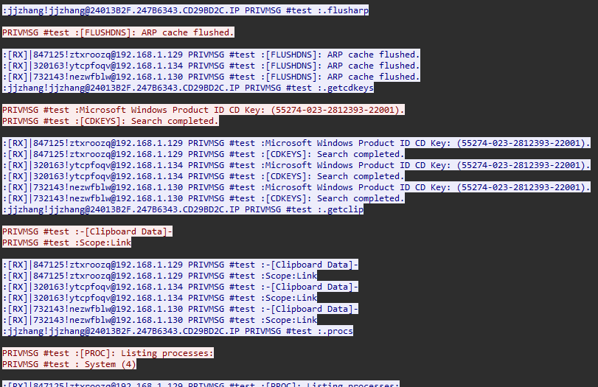
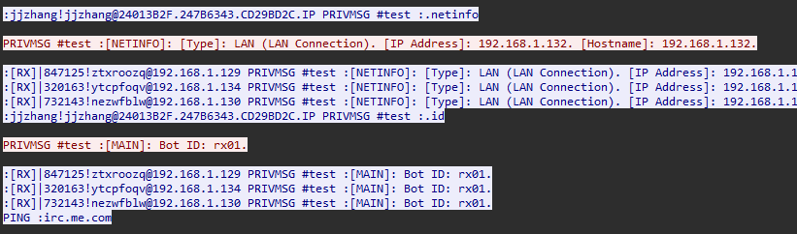

Q11. The botmaster issued the command .advscan netbios 100 5 120 -b -r, instructing each bot to perform TCP SYN scanning of port 139 (NetBIOS) against hosts in the same subnet. Bots should send a large number of TCP SYN packets to that subnet, causing a large number of failed TCP connections. Sometimes, bots do not follow the command. Please identify bots that did not execute this command.
192.168.1.129
192.168.1.130
192.168.1.132
192.168.1.134
Answer: 192.168.1.32 did not execute this command because it didn’t simply reply, as we can in the below stream.
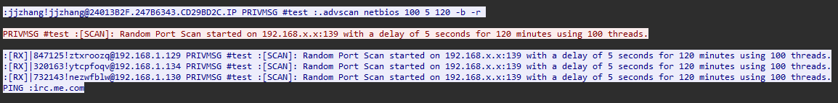

Q12. Which of the following bots likely issued ARP scanning to discover active IP addresses in the local area network?
192.168.1.129
192.168.1.130
192.168.1.132
192.168.1.134
Answer: IP address 192.168.1.130 and 192.168.1.134 likely issued ARP scanning because the two has sent many ARP requests.
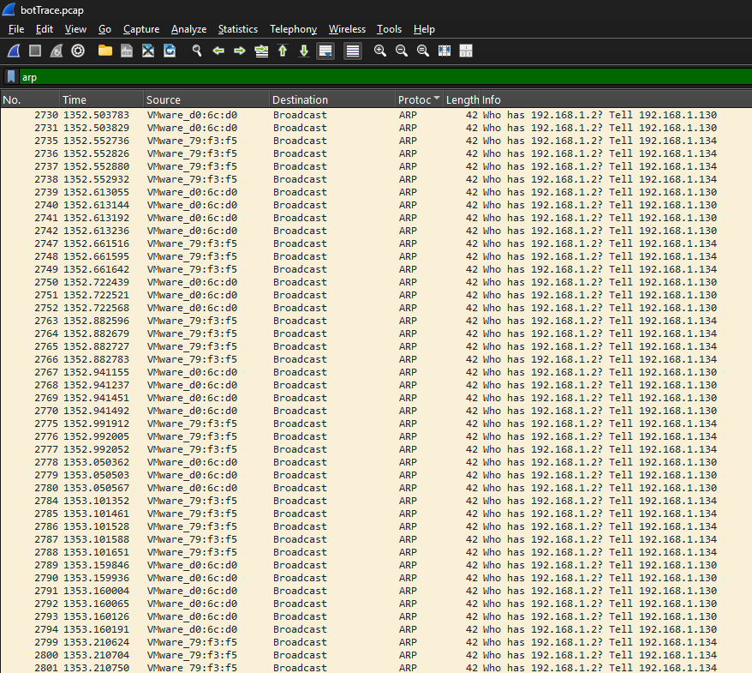
As we can see in the Info column, the info with IP value suffixed .130 and .134 appears abundantly.

